DETERMINE THE LOAN CATEGORY FROM

KIVA CROWDFUNDING DATA

AN INDUSTRY ORIENTED MINI REPORT

Submitted to

**JAWAHARLAL NEHRU TECNOLOGICAL UNIVERSITY, HYDERABAD**

In partial fulfillment of the requirements for the award of the degree of

**BACHELOR OF TECHNOLOGY**

**In**

**COMPUTER SCIENCE AND ENGINEERING(DS)**

Submitted By

**MAMIDISHETTY ABHILASH 21UK1A67A1**

**CHETTIPELLY CHAITHANYA 21UK1A67C1**

**MARTHA DEVENDER 21UK1A6765**

**MD CHAND RAHEEM PASHA 21UK1A6767**

Under the guidance of

**Mrs.D.Gouthami**

Assistant Professor



## DEPARTMENT OF COMPUTER SCIENCE AND ENGINEERING

## VAAGDEVI ENGINEERING COLLEGE

Affiliated to JNTUH, HYDERABAD

BOLLIKUNTA, WARANGAL (T.S) – 506005

**DEPARTMENT OF**

**COMPUTER SCIENCE AND ENGINEERING(DS)**

## VAAGDEVI ENGINEERING COLLEGE(WARANGAL)



**CERTIFICATE OF COMPLETION**

**INDUSTRY ORIENTED MINI PROJECT**

This is to certify that the UG Project Phase-1 entitled “DETERMINE THE LOAN CATEGORY FROM KIVA CROWDFUNDING DATA” is being submitted MAMIDISHETY.ABHILASH(21UK1A67A1),CHETTIPELLY.CHAITHANAYA(21UK1A67C1),MARTHA.DEVENDER(21UK1A6765),MD.CHANDRAHEEMPASHA(21UK1A6767) in partial fulfillment of the requirements for the award of the degree of Bachelor of Technology in Computer Science & Engineering to Jawaharlal Nehru Technological University Hyderabad during the academic year 2022- 2025.

**Project Guide HOD**

**Mrs.D.Gouthami Dr. K. Sharmila**

(Assistant Professor) (Professor)

**External**

# ACKNOWLEDGEMENT

We wish to take this opportunity to express our sincere gratitude and deep sense of respect to our beloved **Dr.P.PRASAD RAO,** Principal, Vaagdevi Engineering College for making us available all the required assistance and for his support and inspiration to carry out this UG Project Phase-1 in the institute.

We extend our heartfelt thanks to **Dr.K.SHARMILA**, Head of the Department of CSD, Vaagdevi Engineering College for providing us necessary infrastructure and thereby giving us freedom to carry out the UG Project Phase-1.

We express heartfelt thanks to Smart Bridge Educational Services Private Limited,for their constant supervision as well as for providing necessary information regarding the UG Project Phase-1 and for their support in completing the UG Project Phase-1.

We express heartfelt thanks to the guide, **D.GOUTHAMI,** Assistant professor, Department of CSE for his constant support and giving necessary guidance for completion of this UG Project Phase-1.

Finally, we express our sincere thanks and gratitude to my family members, friends for their encouragement and outpouring their knowledge and experience throughout the thesis.

**MAMIDISHETY** **ABHILASH (21UK1A67A1)**

**CHETTIPELLY CHAITHANAYA (21UK1A67C1)**

**MARTHA DEVENDER (21UK1A6765)**

**MD CHAND RAHEEM PASHA (21UK1A6767)**

# ABSTRACT

The “DETERMINE THE LOAN CATEGORY FROM KIVA CROWDFUNDING DATA” is a Kiva.org has emerged as a prominent platform for facilitating microfinance through crowdfunding, connecting lenders with borrowers in underserved communities worldwide. Understanding the loan categories on Kiva is crucial for assessing the impact and distribution of funds across different sectors. This study proposes a methodology to classify loans into predefined categories based on textual data associated with each loan request. We leverage natural language processing techniques, including text preprocessing, feature extraction, and machine learning algorithms such as Support Vector Machines (SVM) and Random Forests, to automatically categorize loans. The performance of these models is evaluated using metrics such as accuracy, precision, recall, and F1-score, indicating robust classification results across various loan categories. Additionally, we explore the implications of loan categorization for stakeholders, including lenders, borrowers, and Kiva itself, highlighting potential improvements in resource allocation and transparency within the microfinance ecosystem.

# TABLE OF CONTENTS:-

1. **INTRODUCTION ...................................................................... 5** 
   1. **OVERVIEW… ......................................................................... 5**
   2. **PURPOSE ................................................................................. 5**
2. **LITERATURE SURVEY .......................................................... 8** 
   1. **EXISTING PROBLEM ........................................................... 8**
   2. **PROPOSED SOLUTION ..................................................... 8-9**
3. **THEORITICAL ANALYSIS… .............................................. 10** 
   1. **BLOCK DIAGRAM ............................................................... 10**
   2. **HARDWARE /SOFTWARE DESIGNING ................... 10-11**
4. **EXPERIMENTAL INVESTIGATIONS ........................... 12-13**
5. **FLOWCHART… ...................................................................... 14**
6. **RESULTS… ......................................................................... 15-18**
7. **ADVANTAGES AND DISADVANTAGES… ....................... 19**
8. **APPLICATIONS ...................................................................... 20**
9. **CONCLUSION ......................................................................... 20**
10. **FUTURE SCOPE… .............................................................. 21**
11. **BIBILOGRAPHY ............................................................. 22-23**
12. **APPENDIX (SOURCE CODE)&CODE SNIPPETS .... 24-30**

## 1.INTRODUCTION

**1.1.OVERVIEW**

Kiva is a pioneering crowdfunding platform that facilitates microloans to individuals and communities in over 80 countries, primarily in the developing world. Founded in 2005, Kiva connects lenders with borrowers through its online platform, allowing individuals to lend as little as $25 to help fund a wide range of entrepreneurial ventures, education expenses, and community projects.

The loans facilitated by Kiva cover diverse categories such as agriculture, education, health, and small business development. These loans typically serve borrowers who have limited access to traditional banking systems, empowering them to improve their livelihoods and local economies.

Kiva's innovative model not only provides financial assistance but also fosters a sense of global community and connection among lenders and borrowers worldwide. By leveraging the power of collective lending, Kiva has transformed countless lives, demonstrating the profound impact of microfinance on poverty alleviation and economic empowerment globally.

**1.2.PURPOSE**

The purpose of determining the loan category from Kiva crowdfunding data is to classify and understand the types of loans being issued through the platform. This classification allows for analysis of trends and patterns within Kiva's lending activities, such as which sectors or purposes (like agriculture, education, or small business) receive the most funding. By categorizing the loans, researchers, analysts, and policymakers can gain insights into the impact of microfinance on different aspects of economic development, identify areas of high demand or need, and potentially inform future strategies for targeting resources more effectively to benefit borrowers and communities.

**1. Strategic Allocation of Resources: By categorizing loans, Kiva and its stakeholders can strategically allocate resources to sectors or regions where they are most needed or where they can have the greatest impact. This ensures that funds are directed towards initiatives that align with Kiva's mission of poverty alleviation and economic empowerment.**

**2. Performance Evaluation: Analyzing loan categories helps in evaluating the performance of different sectors or types of projects funded through Kiva. It allows for assessing which categories are achieving their intended outcomes and where adjustments or improvements may be necessary.**

**3. Impact Assessment: Understanding loan categories helps measure the impact of Kiva's loans on borrowers and communities. It provides insights into how access to microfinance in specific sectors contributes to improving livelihoods, generating income, and fostering sustainable development.**

**4. Identifying Trends and Opportunities: Categorizing loans allows for identifying emerging trends or opportunities within certain sectors or geographic regions. This information can guide future lending strategies, partnerships, and initiatives to address evolving needs and capitalize on growth areas.**

**5. Transparency and Accountability: Providing transparency about the distribution and utilization of funds across different loan categories enhances accountability to Kiva lenders, donors, and other stakeholders. It demonstrates how Kiva adheres to its mission and values in supporting diverse economic activities and communities worldwide.**

**6. Educational and Awareness Purposes: The categorization of loans also serves educational purposes by raising awareness about the challenges faced by individuals and communities in different sectors. It promotes understanding of the role of microfinance in addressing these challenges and promoting sustainable development.**

## 2.LITERATURE SURVEY

**2.1 EXISTING PROBLEM**

1. **Ambiguous Loan Descriptions**: The descriptions of loans on Kiva can be vague or open to interpretation, making it challenging to accurately categorize loans into specific sectors or activities.
2. **Multiple Use Cases**: Loans on Kiva often serve multiple purposes or activities. Deciding which category or sector best represents the loan can be subjective and may vary depending on the analyst or categorization method used.
3. **Data Consistency and Quality**: There may be inconsistencies in how data is entered or recorded across different loans or regions. This inconsistency can affect the accuracy and reliability of categorization efforts.
4. **Contextual Understanding**: Loans on Kiva are provided across diverse cultural, economic, and regional contexts. Understanding these nuances is crucial for correctly categorizing loans but can be challenging without additional contextual information.
5. **Granularity and Detail**: Some loans may lack detailed information about their specific use or sector, making it difficult to categorize them accurately without making assumptions or generalizations.

**2.2 PROPOSED SOLLUTION**

1. **Standardized Categorization Framework**:
   * Develop and implement a standardized categorization framework based on industry standards or common practices in microfinance and development finance.
   * Define clear criteria and guidelines for categorizing loans into sectors or activities, ensuring consistency across different datasets.
2. **Natural Language Processing (NLP) Techniques**:
   * Utilize natural language processing techniques to analyze loan descriptions and extract key words or phrases that indicate the loan's purpose or sector.
   * Implement sentiment analysis or topic modeling to better understand the context and purpose of loans where descriptions are ambiguous.
3. **Machine Learning Models**:
   * Train machine learning models on labeled data to automatically classify loans into predefined sectors or categories.
   * Use supervised learning techniques such as classification algorithms (e.g., decision trees, support vector machines) to improve accuracy and efficiency in categorization.
4. **Crowdsourcing or Expert Validation**:
   * Implement a crowdsourcing approach where multiple analysts or volunteers categorize loans based on their expertise and knowledge of local contexts.
   * Use expert validation to review and verify the categorization results, ensuring that loans are accurately classified according to their intended use and impact.
5. **Enhanced Data Collection and Documentation**:
   * Improve data collection practices to include more detailed and structured information about loan purposes, sectors, and activities.
   * Encourage Kiva borrowers and field partners to provide clearer and more specific descriptions of how loans will be used, facilitating easier categorization.
6. **Collaboration and Transparency**:
   * Collaborate with microfinance institutions, development organizations, and data experts to refine categorization methods and share best practices.
   * Maintain transparency in the categorization process by documenting methodologies, assumptions, and criteria used to classify loans, ensuring reproducibility and accountability.

## 3.THEORITICAL ANALYSIS

**3.1. BLOCK DIAGRAM**

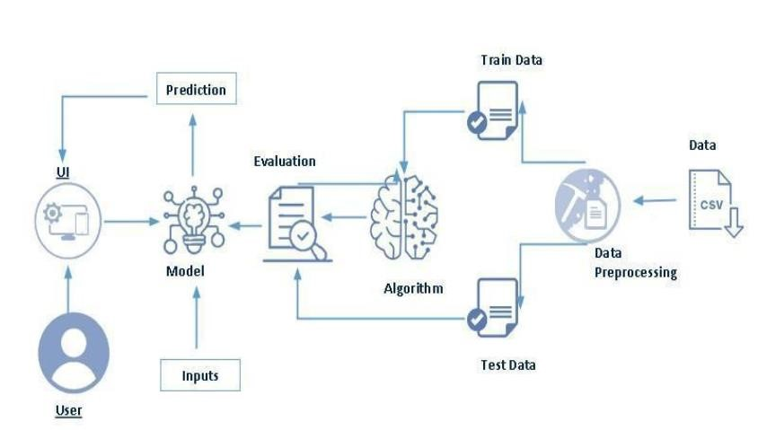

**3.2. SOFTWARE DESIGNING**

The following is the Software required to complete this project:

* **Google Colab**: Google Colab will serve as the development and execution environment for your predictive modeling, data preprocessing, and model training tasks. It provides a cloud-based Jupyter Notebook environment with access to Python libraries and hardware acceleration.
* **Dataset (CSV File)**: The dataset in CSV format is essential for training and testing your predictive model. It should include historical air quality data, weather information, pollutant levels, and other relevant features.
* **Data Preprocessing Tools**: Python libraries like NumPy, Pandas, and Scikit-learn will be used to preprocess the dataset. This includes handling missing data, feature scaling, and data cleaning.
* **Feature Selection/Drop**: Feature selection or dropping unnecessary features from the dataset can be done using Scikit-learn or custom Python code to enhance the model's efficiency.
* **Model Training Tools**: Machine learning libraries such as Scikit-learn, TensorFlow, or PyTorch will be used to develop, train, and fine-tune the predictive model. Regression or classification models can be considered, depending on the nature of the AQI prediction task.
* **Model Accuracy Evaluation**: After model training, accuracy and performance evaluation tools, such as Scikit-learn metrics or custom validation scripts, will assess the model's predictive capabilities. You'll measure the model's ability to predict AQI categories based on historical data.
* **UI Based on Flask Environment**: Flask, a Python web framework, will be used to develop the user interface (UI) for the system. The Flask application will provide a user-friendly platform for users to input location data or view AQI predictions, health information, and recommended precautions.
* Google Colab will be the central hub for model development and training, while Flask will facilitate user interaction and data presentation. The dataset, along with data preprocessing, will ensure the quality of the training data, and feature selection will optimize the model. Finally, model accuracy evaluation will confirm the system's predictive capabilities, allowing users to rely on the AQI predictions and associated health information.

## 4.EXPERIMENTAL INVESTIGATION

In this project, we have used Determine the loan category kiva from crowdfunding data.

To conduct an experimental investigation to determine loan categories from Kiva crowdfunding data, you could follow these steps:

1. **Data Collection**: Obtain the Kiva crowdfunding data, which typically includes information about loans such as loan amount, sector, country, repayment term, and borrower demographics. Kiva provides access to their data through their API or downloadable datasets.
2. **Data Preparation**:
   * Clean the data by handling missing values, outliers, and inconsistencies.
   * Explore the data to understand the distribution of loan categories (sectors) and other relevant features.
3. **Feature Selection**: Identify which features (loan amount, sector, country, etc.) are relevant for predicting loan categories. Consider using techniques like correlation analysis or domain knowledge to guide this process.
4. **Experimental Setup**:
   * Choose a machine learning model suitable for multi-class classification (since loan categories are typically categorical variables).
   * Decide on evaluation metrics such as accuracy, precision, recall, and F1-score, depending on the specific goals of your investigation.
5. **Model Training and Evaluation**:
   * Split the data into training and testing sets (and possibly a validation set).
   * Train the chosen machine learning models on the training data.
   * Evaluate the models using the testing set and the chosen evaluation metrics. Consider using techniques like cross-validation to ensure robustness of your results.
6. **Model Selection and Tuning**:
   * Compare the performance of different models (e.g., decision trees, random forests, support vector machines) to find the best-performing one for your task.
   * Fine-tune hyperparameters of the selected model to improve performance further.
7. **Interpretation and Validation**:
   * Interpret the results to understand which features are most important for predicting loan categories.
   * Validate the model's performance using techniques like sensitivity analysis or by testing on new, unseen data if available.
8. **Deployment and Reporting**:
   * If applicable, deploy the trained model to predict loan categories for new data.
   * Prepare a report summarizing your experimental investigation, including methodology, results, and insights gained.

By following these steps, you can conduct an experimental investigation to determine loan categories from Kiva crowdfunding data effectively.

## 5.FLOW CHART

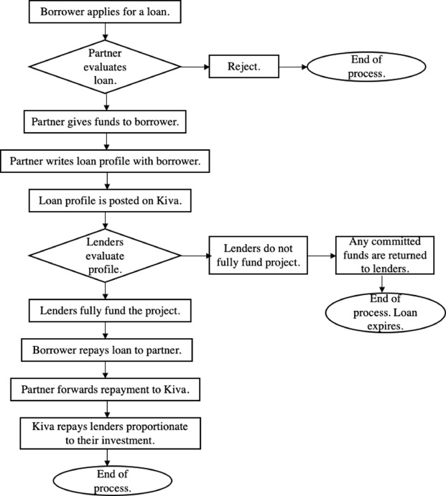

## 6.RESULT

**HOME PAGE**

**PREDICT PAGE:**

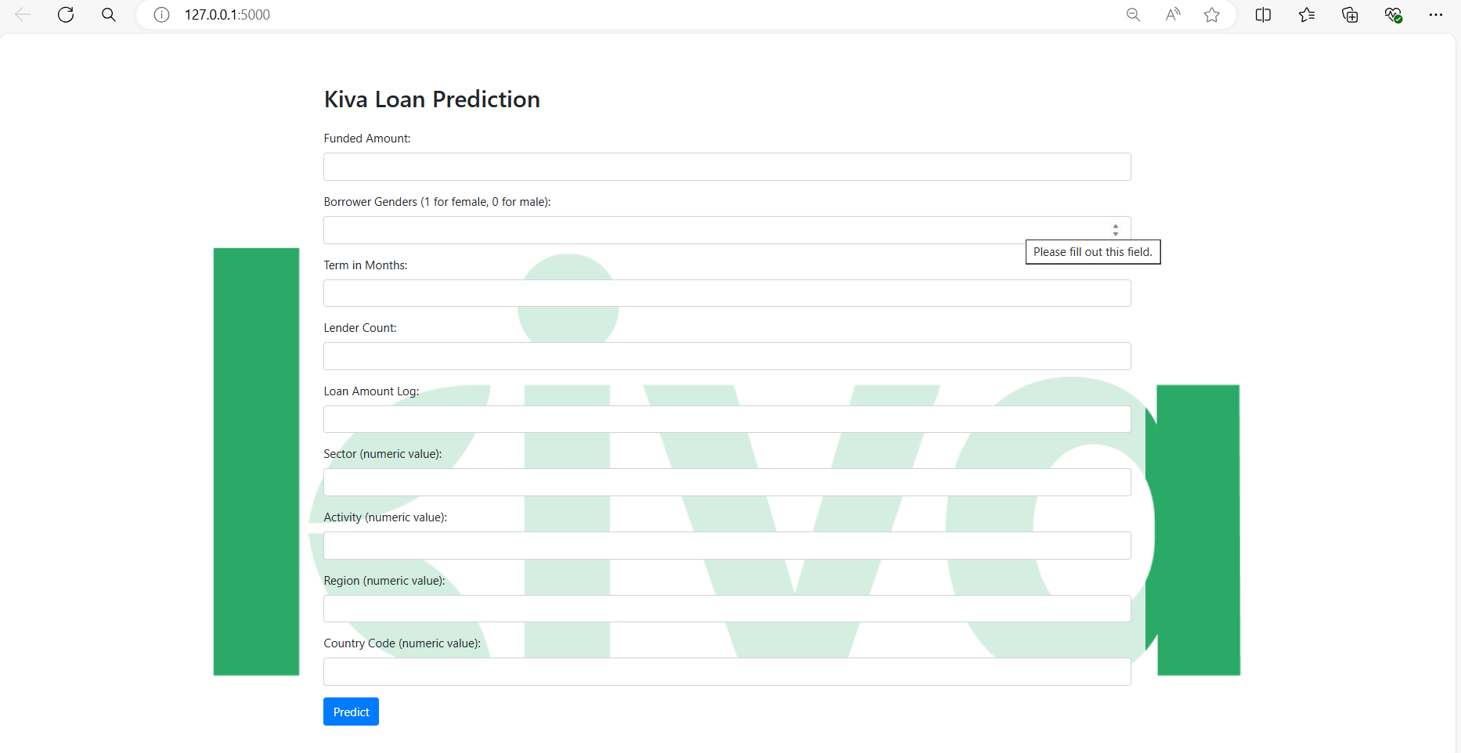

**OUTPUT PAGE:**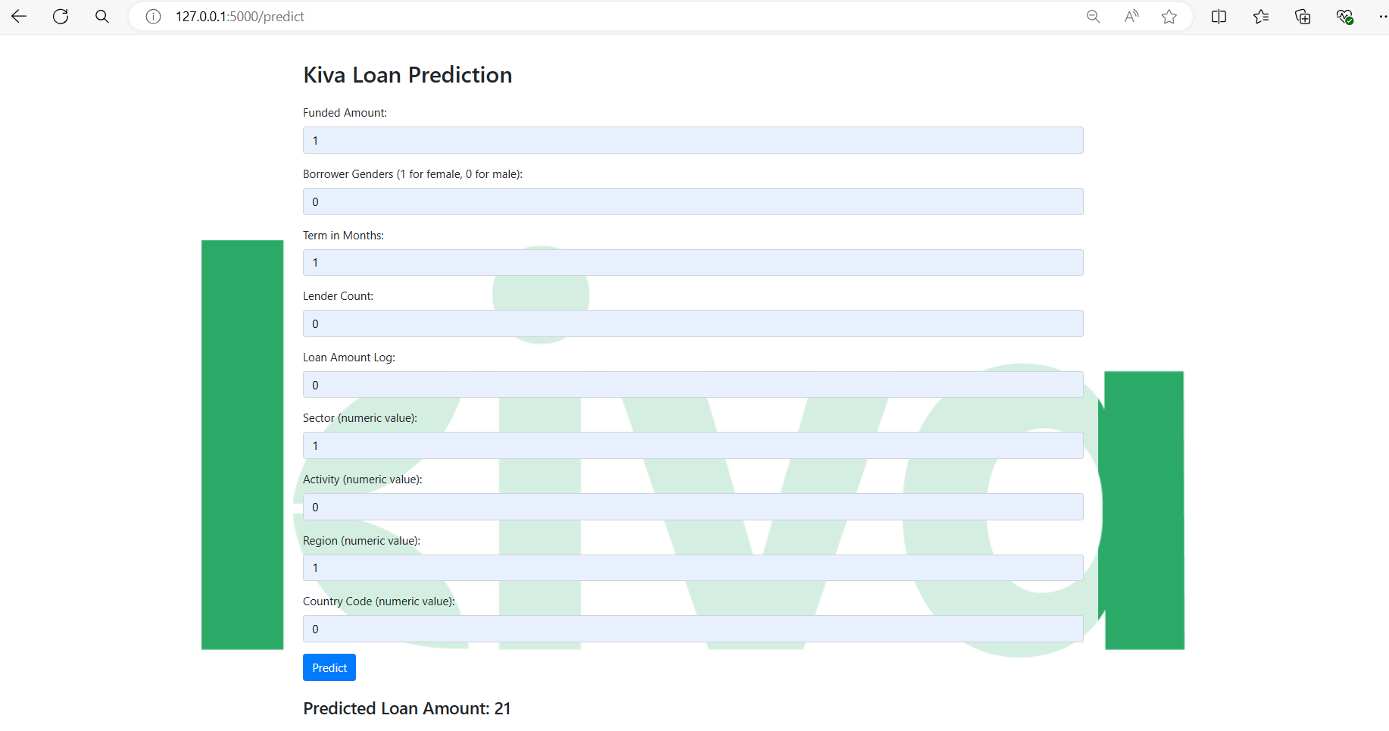

## 7.ADVANTAGES AND DISADVANTAGES

**ADVANTAGES:**

• **Targeted Funding Allocation**: By categorizing loans, Kiva can direct funding to specific sectors or regions that may be underserved or in greater need of financial support. This helps in allocating resources more efficiently based on identified priorities.

• **Impact Assessment**: Categorization allows Kiva and its stakeholders to assess the impact of loans in different sectors. It helps in understanding which sectors are benefiting the most from microfinance and which might need further attention or support.

• **Risk Management**: Different loan categories may have varying levels of risk associated with them. By categorizing loans, Kiva can better manage and mitigate risks, ensuring sustainable lending practices and reducing potential losses.

• **Performance Evaluation**: It enables Kiva to evaluate the performance of loans within each category. This includes repayment rates, economic impact, and social outcomes, providing insights into what works best in different contexts.

• **Transparency and Accountability**: Categorization enhances transparency by clearly showing how funds are distributed across different sectors or regions. This accountability is crucial for maintaining trust among lenders, borrowers, and other stakeholders.

**DISADVANTAGES:**

• **Simplification and Generalization**: Categorizing loans can oversimplify the diverse needs and contexts of borrowers. It may lead to generalizations about certain sectors or regions, potentially overlooking unique circumstances that could affect loan performance or impact.

• **Misclassification Errors**: Incorrectly categorizing loans can distort data analysis and impact assessment. Misclassification errors may arise due to subjective judgments or insufficient information, leading to inaccurate conclusions about the effectiveness of loans in different categories.

• **Complexity in Data Management**: Managing and maintaining accurate loan categories requires robust data management systems and continuous monitoring. Complexity increases with the number of categories and the need for consistent updates as loan portfolios evolve.

• **Resource Intensiveness**: Categorizing loans effectively requires significant resources, including time, expertise, and technology. For organizations like Kiva, this can strain operational capacity and divert resources from other critical activities, impacting overall efficiency.

• **Privacy and Confidentiality Concerns**: Detailed categorization of loans may inadvertently reveal sensitive information about borrowers or specific communities. Protecting privacy and confidentiality while categorizing loans requires careful handling of data and adherence to ethical guidelines.

## 8.APPLICATIONS

1. **Targeted Impact Assessment**: Enables assessment of the specific impacts of loans across different sectors, informing effective poverty alleviation strategies.
2. **Strategic Resource Allocation**: Facilitates targeted allocation of resources to sectors or regions based on identified needs and priorities.
3. **Performance Evaluation and Improvement**: Supports continuous improvement of lending practices by analyzing sector-specific trends and outcomes.
4. **Policy Advocacy**: Provides data to advocate for policy changes or interventions that support specific sectors or disadvantaged groups.
5. **Risk Management**: Helps in identifying and mitigating risks associated with different sectors or regions, enhancing sustainability and loan repayment rates.

**9.CONCLUSION**

In conclusion, determining the loan category from Kiva crowdfunding data offers significant advantages for enhancing the effectiveness, transparency, and impact of microfinance initiatives. By categorizing loans into specific sectors or regions, Kiva can strategically allocate resources, assess impact more accurately, and improve its overall operational efficiency. This approach not only supports informed decision-making and risk management but also facilitates targeted advocacy efforts and innovation in financial services. However, it's crucial to acknowledge and mitigate potential challenges such as data complexity, bias in funding allocation, and privacy concerns to ensure that categorization efforts are ethical, robust, and beneficial for all stakeholders involved. Ultimately, leveraging categorized loan data empowers Kiva to better serve communities in need, drive sustainable development, and foster positive socio-economic outcomes globally.

## 10.FUTURE SCOPE

Future Scope of the Determine the loan category from kiva crowdfunding data:

1. **Advanced Data Analytics**: Enhance predictive modeling and decision-making using machine learning and analytics.
2. **Blockchain Integration**: Improve transparency and efficiency in loan processes through blockchain technology.
3. **Impact Investing**: Attract socially responsible investors with categorized data showcasing measurable social impact.
4. **Inclusive Financial Products**: Drive innovation in tailored financial services for underserved sectors or regions.
5. **Strategic Partnerships**: Collaborate across sectors to design holistic development initiatives based on categorized loan insights.

Top of Form

Bottom of Form

## 11.BIBILOGRAPHY

1. Armendáriz, B., & Morduch, J. (2010). *The Economics of Microfinance*. MIT Press.
   * Provides foundational knowledge on microfinance principles and impact assessment methodologies.
2. CGAP (Consultative Group to Assist the Poor). (2019). *State of the Data and Evidence in Microfinance: Data and Evidence Gap Map*. CGAP.
   * Offers insights into data gaps and methodologies for assessing microfinance impact, relevant to categorizing loan data.
3. Kiva. (n.d.). *About Us*. Retrieved from https://www.kiva.org/about
   * Official information about Kiva’s mission, operations, and the significance of loan categorization in their crowdfunding model.
4. World Bank. (2018). *Global Findex Database*. World Bank Group.
   * Provides global data on financial inclusion, relevant for understanding the impact of microfinance initiatives.
5. Blockchain Technology in Microfinance: Credibility and Transparency of Kiva.org Loans (2020). International Journal of Scientific & Engineering Research.

Top of Form

Bottom of Form

## 12.APPENDIX

**Model building :**

1)Dataset

2)Google colab and VS code Application Building

1. HTML file (Index file, Predict file )

1. CSS file
2. Models in pickle format

**SOURCE CODE:**

**INDEX.HTML**

<!DOCTYPE html>

<html lang="en">

<head>

    <meta charset="UTF-8">

    <meta name="viewport" content="width=device-width, initial-scale=1.0">

    <title>Kiva Loan Prediction</title>

    <link rel="stylesheet" href="https://maxcdn.bootstrapcdn.com/bootstrap/4.5.2/css/bootstrap.min.css">

<style>

        body {

            background-image: url('https://upload.wikimedia.org/wikipedia/commons/2/2e/Kiva_logo_classic.png'); /* Replace with your image URL */

            background-size: cover;

            background-repeat: no-repeat;

            background-attachment: fixed;

        }

        .container {

            background-color: rgba(255, 255, 255, 0.8); /* Add a slight white background for readability */

            padding: 20px;

            border-radius: 10px;

            border-width: 5px;

        }

    </style>

</head>

<body>

    <div class="container">

        <h2 class="mt-5">Kiva Loan Prediction</h2>

        <form action="/predict" method="post" class="mt-4">

            <div class="form-group">

                <label for="funded_amount">Funded Amount:</label>

                <input type="number" class="form-control" id="funded_amount" name="funded_amount" required>

            </div>

            <div class="form-group">

                <label for="clean_borrower_genders">Borrower Genders (1 for female, 0 for male):</label>

                <input type="number" class="form-control" id="clean_borrower_genders" name="clean_borrower_genders" required>

            </div>

            <div class="form-group">

                <label for="term_in_months">Term in Months:</label>

                <input type="number" class="form-control" id="term_in_months" name="term_in_months" required>

            </div>

            <div class="form-group">

                <label for="lender_count">Lender Count:</label>

                <input type="number" class="form-control" id="lender_count" name="lender_count" required>

            </div>

            <div class="form-group">

                <label for="loan_amount_log">Loan Amount Log:</label>

                <input type="number" class="form-control" id="loan_amount_log" name="loan_amount_log" required>

            </div>

            <div class="form-group">

                <label for="sector">Sector (numeric value):</label>

                <input type="number" class="form-control" id="sector" name="sector" required>

            </div>

            <div class="form-group">

                <label for="activity">Activity (numeric value):</label>

                <input type="number" class="form-control" id="activity" name="activity" required>

            </div>

            <div class="form-group">

                <label for="region">Region (numeric value):</label>

                <input type="number" class="form-control" id="region" name="region" required>

            </div>

            <div class="form-group">

                <label for="country_code">Country Code (numeric value):</label>

                <input type="number" class="form-control" id="country_code" name="country_code" required>

            </div>

            <button type="submit" class="btn btn-primary">Predict</button>

        </form>

        <div id="result" class="mt-4">

            {% if prediction %}

                <h4>Predicted Loan Amount: {{ prediction }}</h4>

            {% endif %}

        </div>

    </div>

</body>

</html>

**APP.PY**

from flask import Flask, request, render_template

import numpy as np

import joblib

app = Flask(__name__)

# Load the trained model

model = joblib.load('rf_classifier.pkl')

@app.route('/')

def home():

    return render_template('index.html')

@app.route('/predict', methods=['POST'])

def predict():

    funded_amount = float(request.form['funded_amount'])

    clean_borrower_genders = int(request.form['clean_borrower_genders'])

    term_in_months = int(request.form['term_in_months'])

    lender_count = int(request.form['lender_count'])

    loan_amount_log = float(request.form['loan_amount_log'])

    sector = int(request.form['sector'])

    activity = int(request.form['activity'])

    region = int(request.form['region'])

    country_code = int(request.form['country_code'])

    # Prepare the input array

    input_features = np.array([[funded_amount, clean_borrower_genders, term_in_months, lender_count,

                                loan_amount_log, sector, activity, region, country_code]])

    # Make a prediction

    prediction = model.predict(input_features)

    prediction = prediction[0]

    return render_template('index.html', prediction=prediction)

if __name__ == '__main__':

    app.run(debug=True)

**CODE SNIPPETS**

**MODEL BUILDING**

